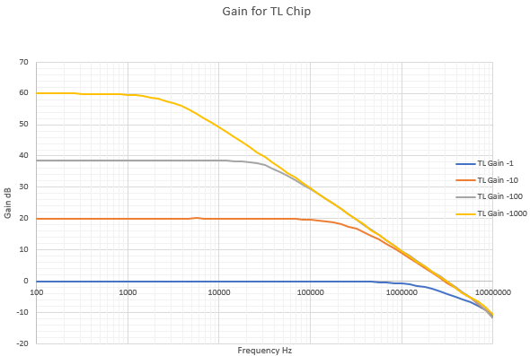Frequency Response Anabysis 
L]SB device installed ας "usb". 
Gain, Phase Frequency 
100Η2 
1.0k 
1.0M 
94 
47 
-235 
10M 

z20pF 
12예F G BW vs Gain 
i 
10m 